**Course:** High Performance Computing Lab

**Practical No. 6**

PRN: 22510057

Name: Ashutosh Gundu Birje

Batch: B8

**Title of practical:**

Installation of MPI & Implementation of basic functions of MPI

**Problem Statement 1:**

Implement a simple hello world program by setting number of processes equal to 10

**Program**

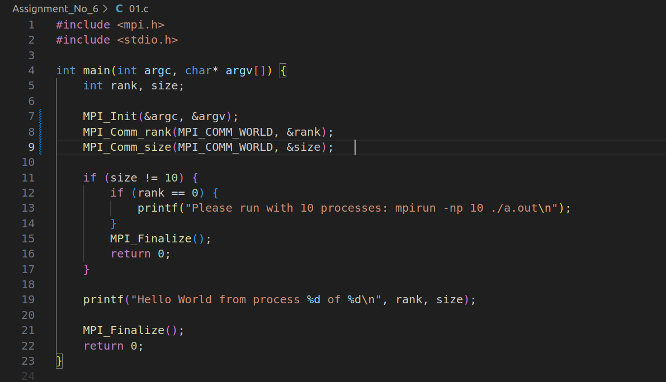

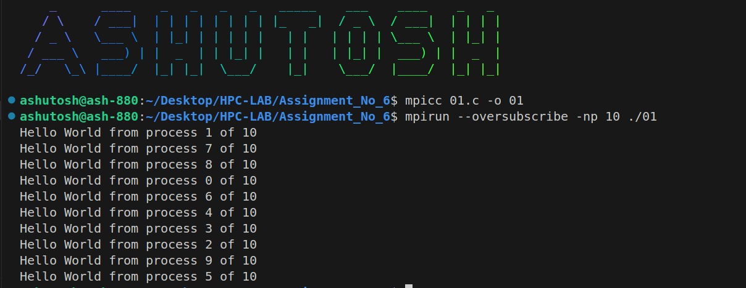**Screenshot:**

**Problem Statement 2:**

Implement a program to display rank and communicator group of five processes

**Program:**

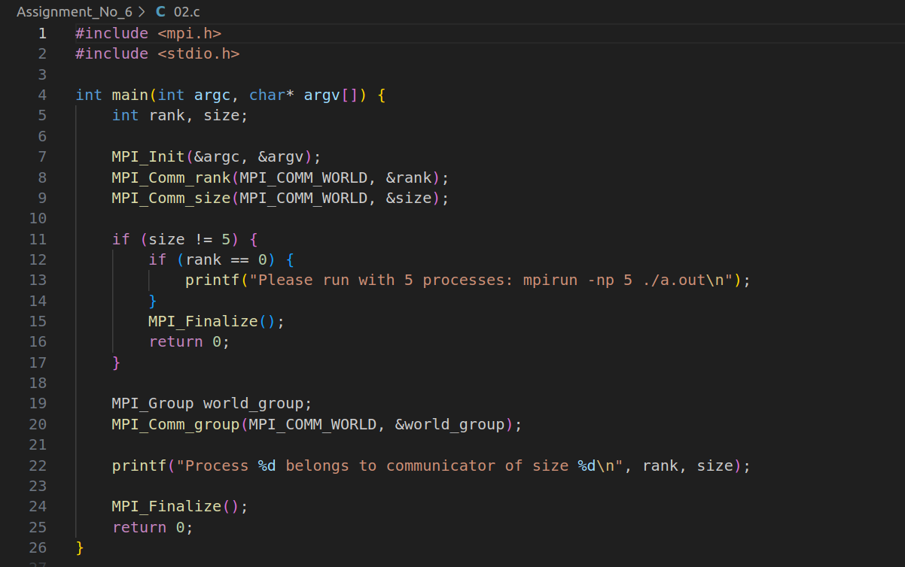

**Screenshot:**

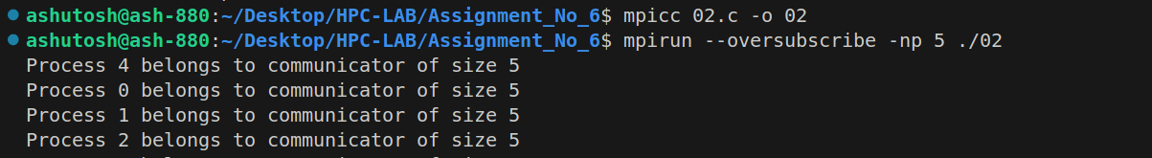

**Q3: Implement a MPI program to give an example of Deadlock.**

**Program:**

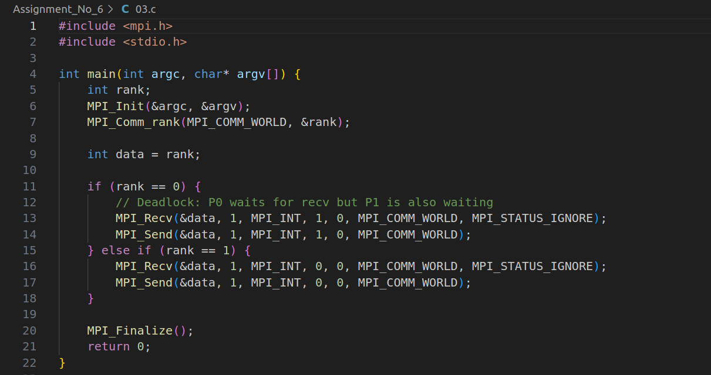

**Screenshot:**



**Q4. Implement blocking MPI send & receive to demonstrate Nearest neighbor exchange of data in a ring topology.**

**Program**

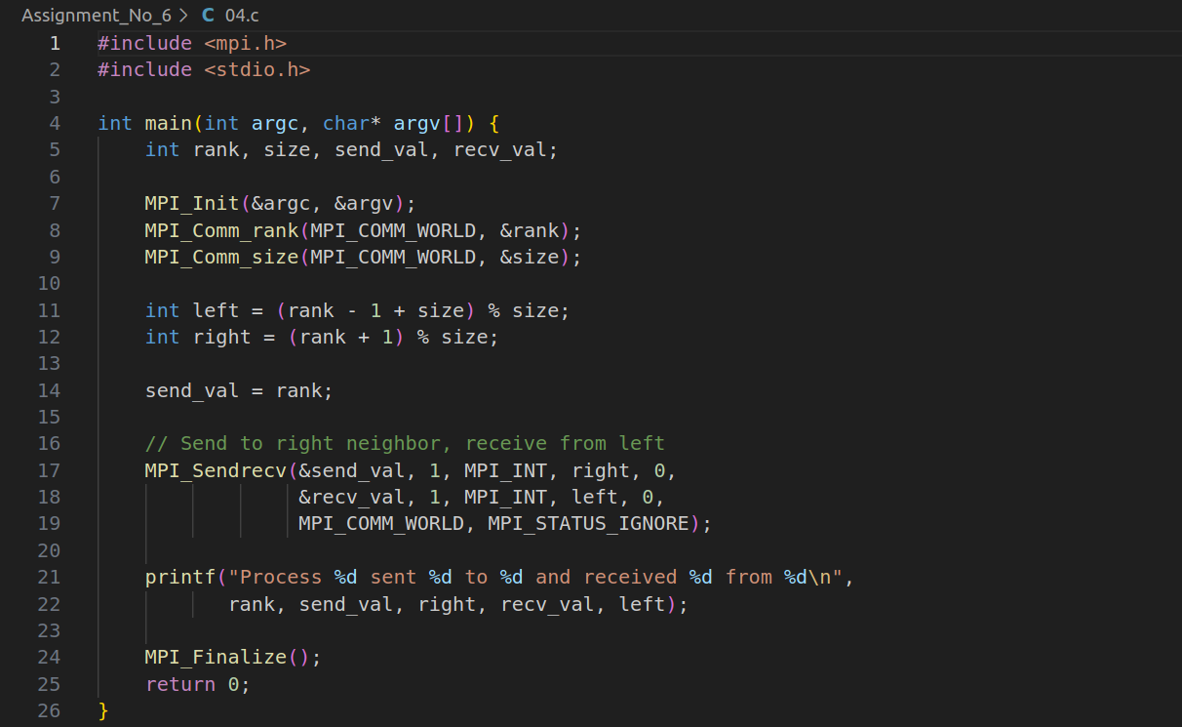

**Screenshot:**

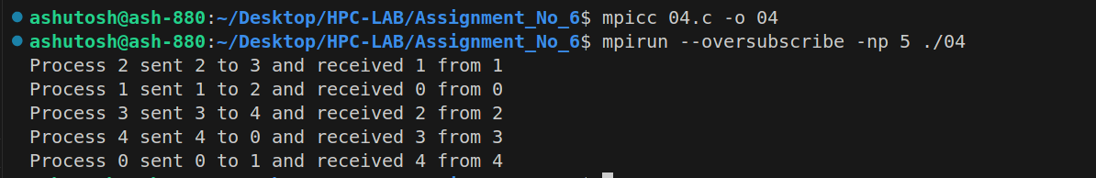

**Q5. Write a MPI program to find the sum of all the elements of an array A of size**

**n. Elements of an array can be divided into two equals groups. The first [n/2]**

**elements are added by the first process, P0, and last [n/2] elements the by second process, P1. The two sums then are added to get the final result.**

**Program**

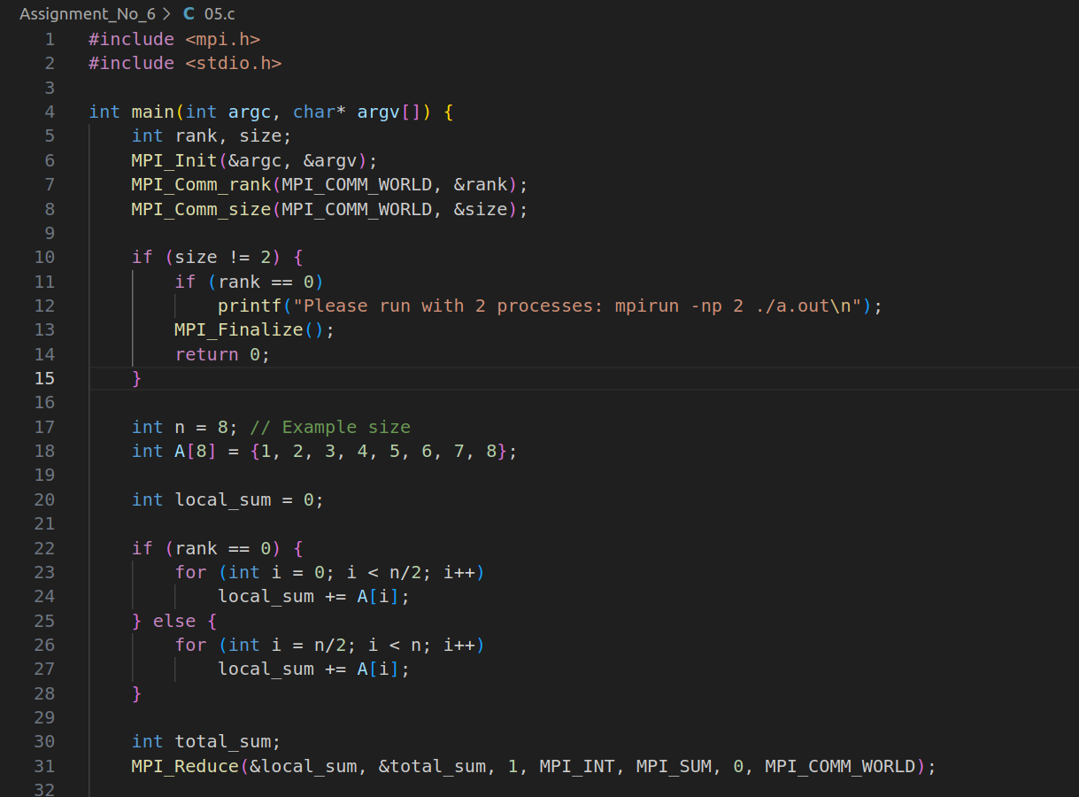

**Screenshot:**

